**Internet of Things**

**Critical Analysis**

bit.ly/3vTYAA2

|  |  |
| --- | --- |
| Name | Alekss Belavskis |
| Date | 26/04/2024 |
| Student No | S00253368 |
| Student Email | s00253368@atu.ie |

### **Critical Analysis** [**- see slides here**](https://docs.google.com/presentation/d/193MMMz7EaoHWorLezZqeiO9gTh3cI20Jm06GoyJhtnw/edit?usp=sharing)

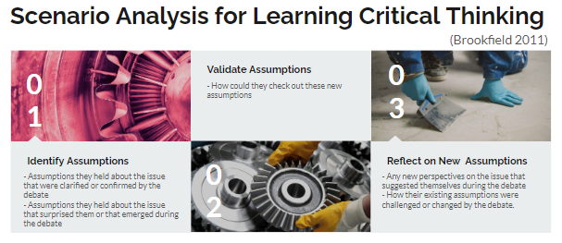

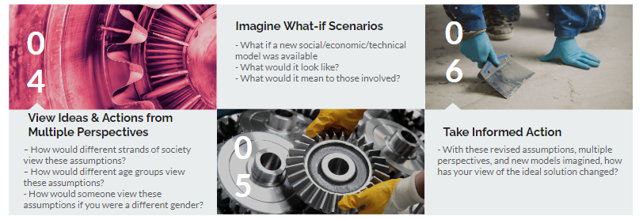

|  |
| --- |
| **Draw the variables in your system in the format of a Bayesian Network**  1. Draw the node you are trying to optimise in your system - e.g. OPTIMISE HYDRATION 2. Draw each node that will influence this dependent variable 3. Draw edges between nodes that influence each other 4. Calculate percentages of probabilities for each node (should add up to 100%)  Individual Diagram Group Diagram |

### 

|  |  |
| --- | --- |
| Overall System | AI Elements of the system |
| **What *effect* does your system have?****On individuals?** Worry-free and comfortable living experience **On society?** Safer and more reliable infrastructure |  |

### **2. Identify Assumptions**

**What assumptions did you make in designing your system?**

|  |  |
| --- | --- |
| Overall System | AI Elements of the system |
| 1. People would like to keep a room monitor in their room  2. People will know how to set up and use the room monitor  3. People are interesting in tracking the conditions of their room  4. People would like to make their living conditions easier  5. People are willing to pay for a room monitor  6. The room monitor provides a practical benefit for the users |  |

### **3. Validate Assumptions**

**How could you check whether these assumptions are true?**

|  |  |
| --- | --- |
| Overall System | AI Elements of the system |
| 1. Survey how many people use/want monitoring gadgets  2. Conduct user testing to see how able they are to set it up  3. Survey people to see if they would like to track the conditions of their room  4. Survey people to see if they are affected negatively or positively by their living conditions  5. Survey to see how much people are willing to pay for a room monitor  6. Ask people who own room monitoring devices about what it provides them |  |

### **4. Reflect on New Assumptions**

**What new insights have you gained by identifying and validating your assumptions?**

|  |  |
| --- | --- |
| Overall System | AI Elements of the system |
| 1. We know that we’re providing for a demand in the market.  2. We should include a user manual with the product to help set it up  3. There is an interest for users to buy a simple monitoring device in their room  4. People are often too warm/too cold in their homes and want an easy way to control it  5. There are people who are willing to pay for a room monitor  6. A room monitoring device can save people’s time and money |  |

### **5. Consider Different Perspectives**

**How does your system design, ideas & actions look from Multiple Perspectives e.g. perspective people of different ages, different socioeconomic backgrounds, different genders, different types of business people, different types of investors, different nationalities, differently abled people etc?**

|  |  |
| --- | --- |
| Overall System | AI Elements of the system |
| 1. People from countries who are not used to the temperature may be more inclined to control it to a more comfortable level  2. Accessible to all nationality groups (Celsius in Europe, Fahrenheit in America)  3. Usability for people in both home and professional settings (server rooms)  4. Accessible controls for differently abled individuals  5. Availability in multiple languages so that non-English speakers can also use the product  6. User-friendly interface that by extension helps neuro-diverse people |  |

### **6. Imagine What-if Scenarios**

**Can you re-imagine your system, or the environments and people using, it to unlock new creative possibilities? What do you imagine could be possible in the future?**

|  |  |
| --- | --- |
| Overall System | AI Elements of the system |
| 1. The room monitor could control a central heating system in your house  2. The room monitor could make predictions about future conditions  3. The room monitor could control smart lighting systems in your home based on climate data  4. The room monitor could create different kinds of alerts or contact certain people in the case of detection of adverse conditions  5. The room monitor could integrate with smart locks or security cameras, to enhance automation and safety  6. The room monitor could connect to a healthcare service and track environmental conditions that could impact health, such as air quality or temperature. This can provide reassurance for elderly or other vulnerable people. |  |

### **7. Take Informed Action**

**Having gone through this Critical Analysis exercise, what would you change about your system and why?**

|  |  |
| --- | --- |
| Overall System | AI Elements of the system |
| 1. We would enhance the accessibility of the room monitor, for example, by adding voice controls.  2. We would expand the language and regional options available in our room monitor and mobile app  3. We would make sure the room monitor has appropriate security so that it can’t be exploited as a weak link in a network of devices.  4. We would implement machine learning to be able to predict the future climate or lighting conditions in a room.  5. We would create an online forum where users of the product can contribute with discussions and ideas that we can use to improve the product for them.  6. We would include a physical and digital user manual to help users with setting up, maintaining, and configuring the product. |  |

### **8. Draw a refined version of your BN Diagram from Step 1 - taking into account your Critical Analysis in Steps 2-7**

1. Draw the node you are trying to optimise in your system
2. Draw each node that will influence this dependent variable
3. Draw edges between nodes that influence each other
4. Calculate percentages of probabilities for each node (should add up to 100%)

### 